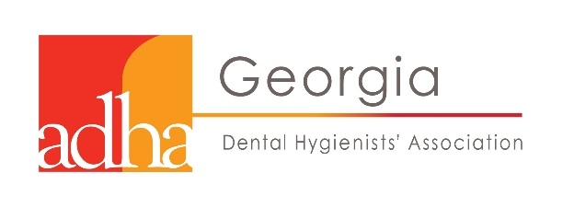

Georgia Dental Hygienists' Association Outstanding
G.D.H.A. Volunteer of the Year

Name: ______________________________________________________________________
Address: ______________________________________________________________________
______________________________________________________________________
Contact Number: (_______) ___________________________Cell or Home (circle one)
Work Phone: (_______) ___________________________________
​Component: ________________________________________________________
Nominated by: ______________________________________________________

Comments: Write a brief narrative explaining the reasons for nominating the candidate for this award. The award is based on the current years’ service. Please be as specific as possible in the narrative explaining the service of the candidate.
A nominee information form will be forwarded to the candidate upon receipt of this form.
Deadline for submission is two months before the GDHA Annual Conference

Return completed form to the VOTY Awards Chair Barbara Harrison at: bhdh72@bellsouth.net

