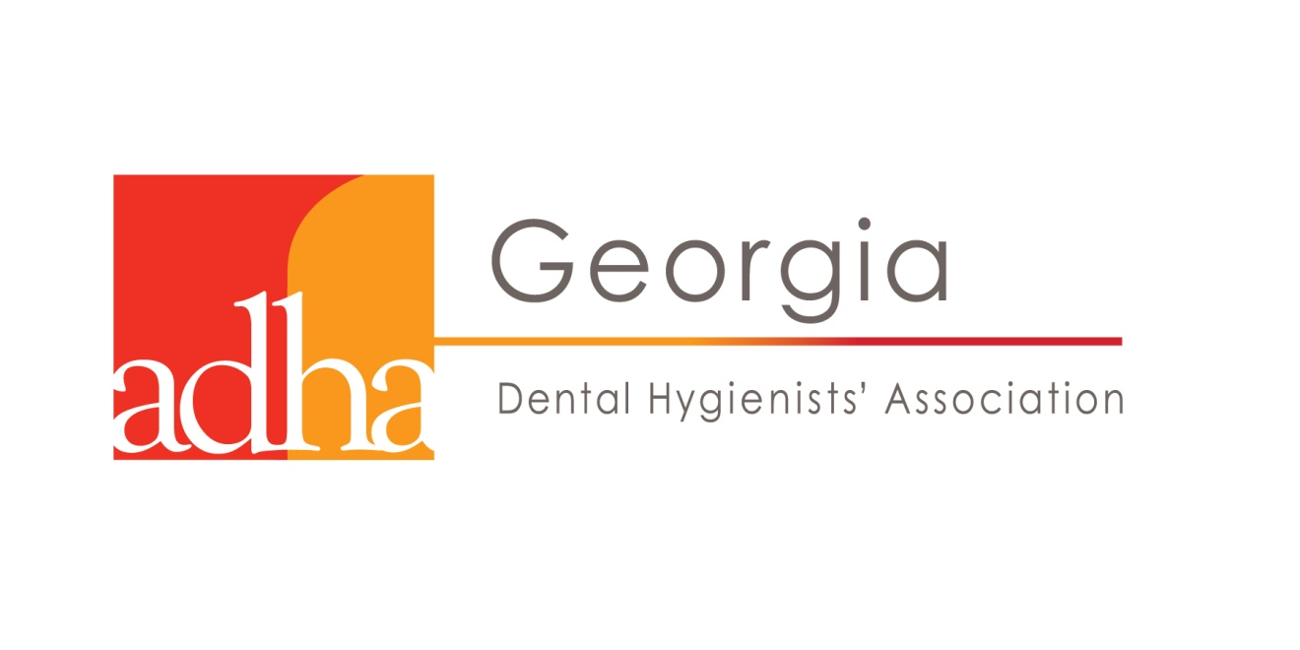
OUTSTANDING DENTIST OF THE YEAR APPLICATION
The GEORGIA DENTAL HYGIENISTS’ ASSOCIATION offers this award to a Georgia dentist who has shown exemplary respect and support of the dental hygiene community
Criteria: nominations must come from a GDHA hygienist and the nominee must be a licensed Georgia dentist.
Nominee’s Name ____________________________________________________
Nominee’s Address _______________________________________________________
________________________________________________________________________
******************************************************************************************************************************************************************************************
Nominator’s Name ____________________________________________________
ADHA # __________
Nominator’s Address _______________________________________________________
_________________________________________________________________________
Contact # _________________________________________________________________
Email Address _____________________________________________________________
Relationship to the Nominee __________________________________________________
Please explain, in 200 words or less, why you are nominating this individual for this award. Please include humanitarian efforts, hobbies, personal/professional awards/accolades and how this individual has shown support for the profession of dental hygiene.
Return completed nomination to the GDHA Awards Chair, Barbara Harrison at: bhdh72@bellsouth.net

